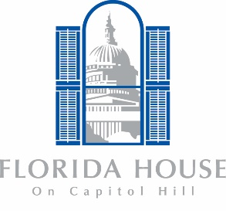
Florida House
Donation Form

Name
Address
City |  |  | State |  |  | Zip Code
Telephone
Email Address

I am making a tax-deductible gift of:
☐ $50 ☐ $100 ☐ $500 ☐ $1,000 ☐ Other ______

Please make your check payable to Florida House and mail it with this form to: Florida House, 1 Second Street NE, Washington, D.C. 20002.
Or fill in the following to charge to your credit card:
Authorized Signature |  |  | Date
Account Number |  |  | Expiration Date

